**VISVESVARAYA TECHNOLOGICAL UNIVERSITY**

**“JnanaSangama”, Belgaum -590014, Karnataka.**



**LAB REPORT**

**on**

**Artificial Intelligence (23CS5PCAIN)**

***Submitted by***

**Skanda Mahesh(1BM23CS332)**

***in partial fulfillment for the award of the degree of***

**BACHELOR OF ENGINEERING**

***in***

**COMPUTER SCIENCE AND ENGINEERING**



**B.M.S. COLLEGE OF ENGINEERING**

**(Autonomous Institution under VTU)**

**BENGALURU-560019**

**Aug 2025 to Dec 2025**

**B.M.S. College of Engineering,**

**Bull Temple Road, Bangalore 560019**

(Affiliated To Visvesvaraya Technological University, Belgaum)

**Department of Computer Science and Engineering**



**CERTIFICATE**

This is to certify that the Lab work entitled “Artificial Intelligence (23CS5PCAIN)” carried out by Skanda Mahesh **(1BM23CS332),** who is bonafide student of **B.M.S. College of Engineering.** It is in partial fulfilment for the award of **Bachelor of Engineering in Computer Science and Engineering** of the Visvesvaraya Technological University, Belgaum. The Lab report has been approved as it satisfies the academic requirements in respect of an Artificial Intelligence (23CS5PCAIN) work prescribed for the said degree.

|  |  |
| --- | --- |
| Lab faculty Incharge Name  Assistant Professor  Department of CSE, BMSCE | Dr. Kavitha Sooda  Professor & HOD  Department of CSE, BMSCE |

**Index**

|  |  |  |  |
| --- | --- | --- | --- |
| **Sl.**  **No.** | **Date** | **Experiment Title** | **Page No.** |
| 1 | 18-8-25 | Implement Tic –Tac –Toe Game  Implement vacuum cleaner agent | 4 |
| 2 | 1-9-25 | Implement 8 puzzle problems using Depth First Search (DFS)  Implement Iterative deepening search algorithm | 10 |
| 3 | 8-9-25 | Implement A* search algorithm | 13 |
| 4 | 15-09-25 | Implement Hill Climbing search algorithm to solve N-Queens problem | 17 |
| 5 | 15-09-25 | Simulated Annealing to Solve 8-Queens problem | 17 |
| 6 | 22-09-25 | Create a knowledge base using propositional logic and show that the given query entails the knowledge base or not. | 20 |
| 7 | 13-10-25 | Implement unification in first order logic | 22 |
| 8 | 13-10-25 | Create a knowledge base consisting of first order logic statements and prove the given query using forward reasoning. | 26 |
| 9 | 16-12-2024 | Create a knowledge base consisting of first order logic statements and prove the given query using Resolution | 32 |
| 10 | 16-12-2024 | Implement Alpha-Beta Pruning. | 35 |

Github Link: https://github.com/Skanda-Mahesh/AI-lab

**Program 1**

Implement Tic –Tac –Toe Game

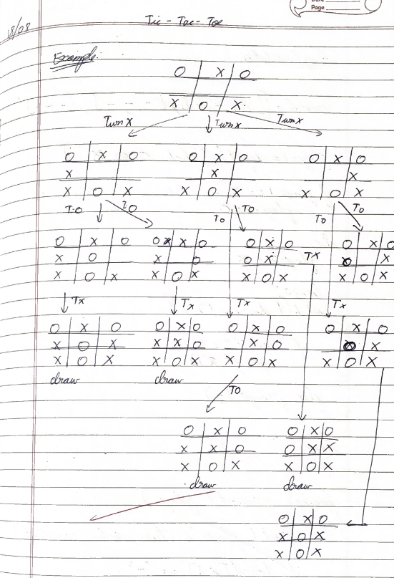 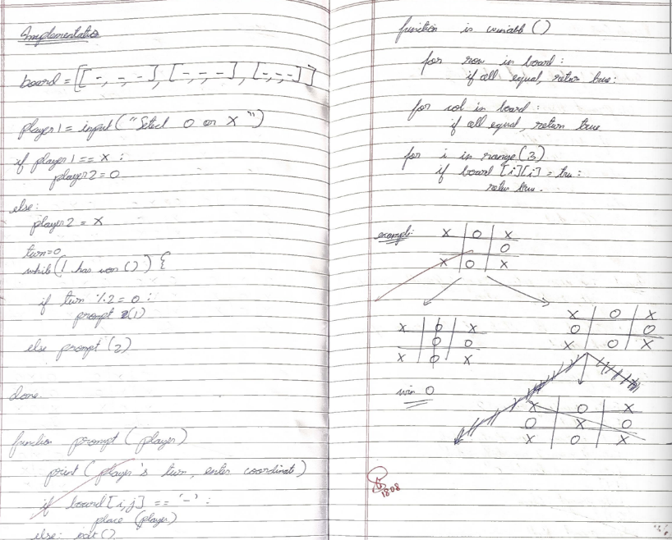

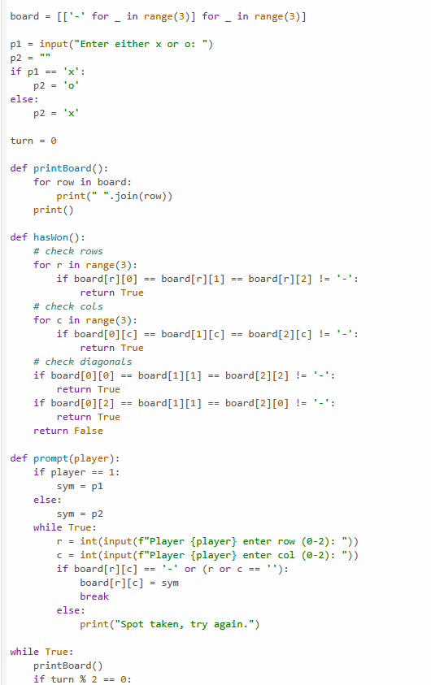 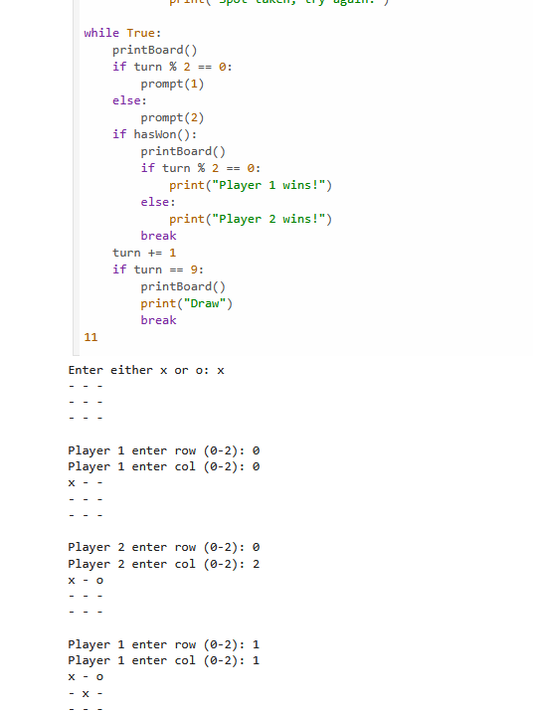

Vacuum cleaner problem

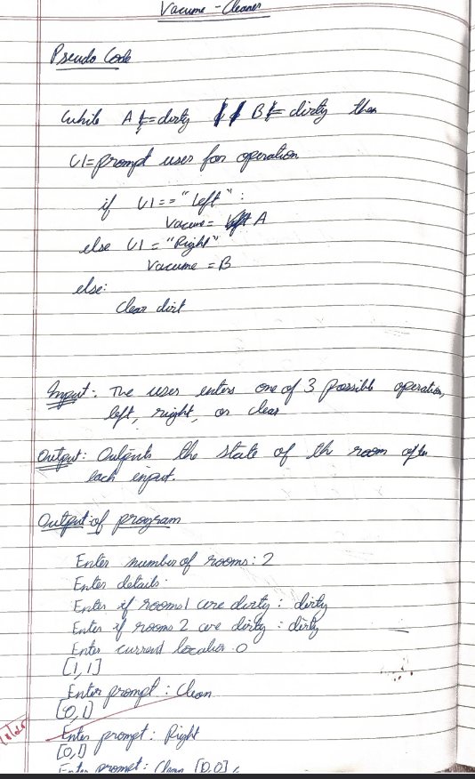

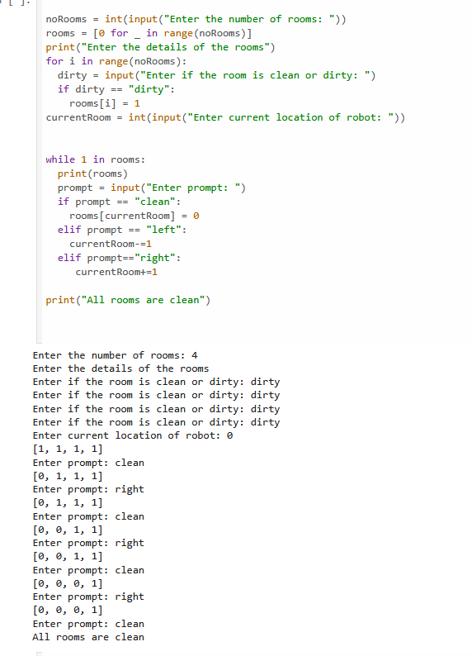

**Program 2**

Implement 8 puzzle problems using Depth First Search (DFS)

Implement Iterative deepening search algorithm

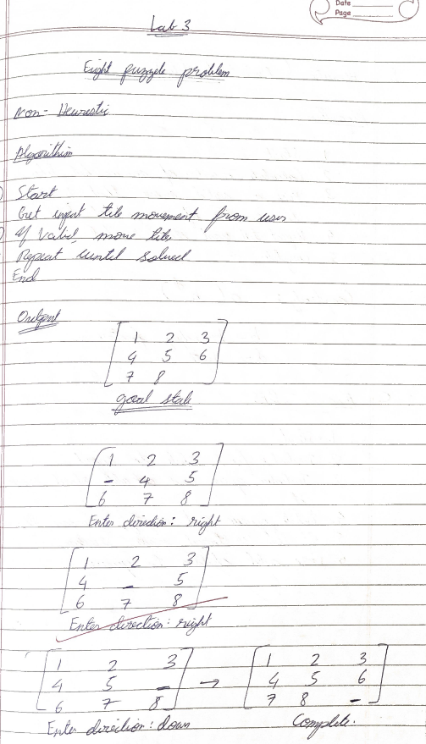

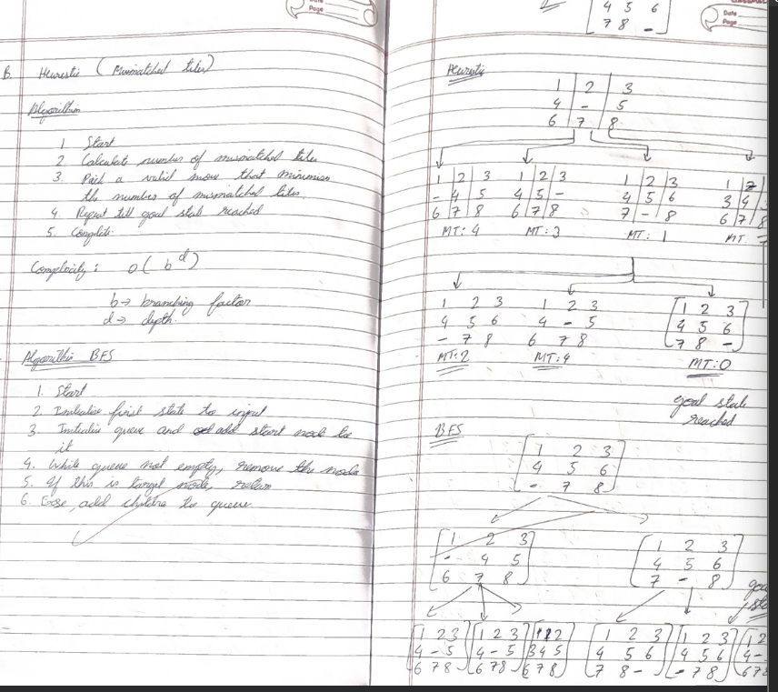

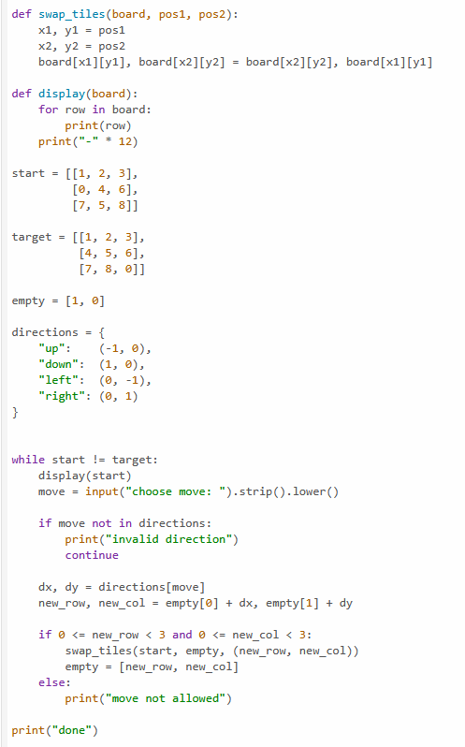

**Program 3**

Implement A* search algorithm 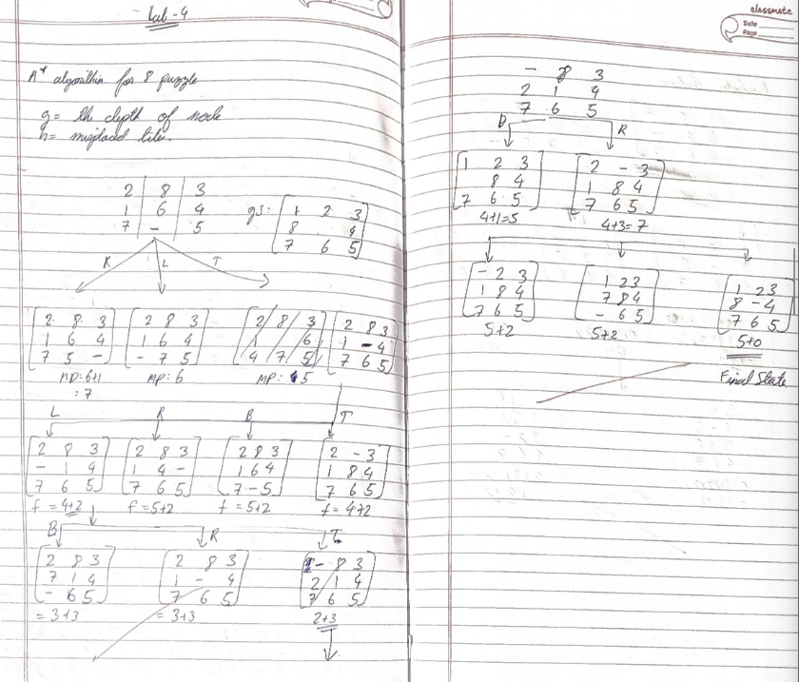

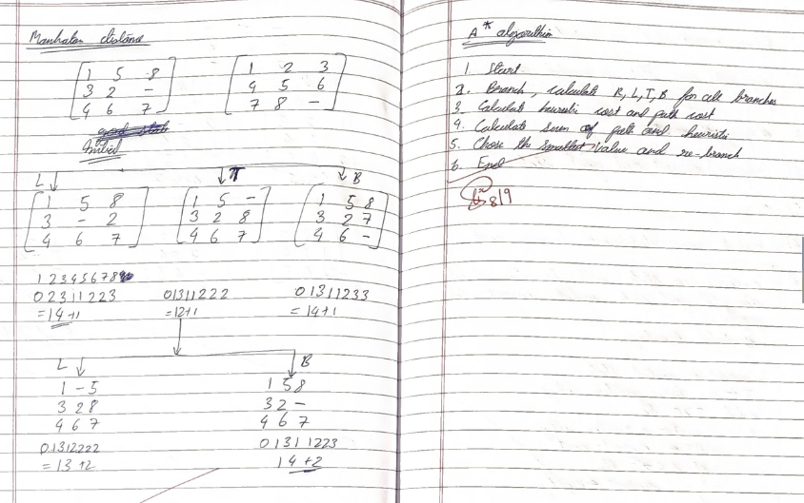

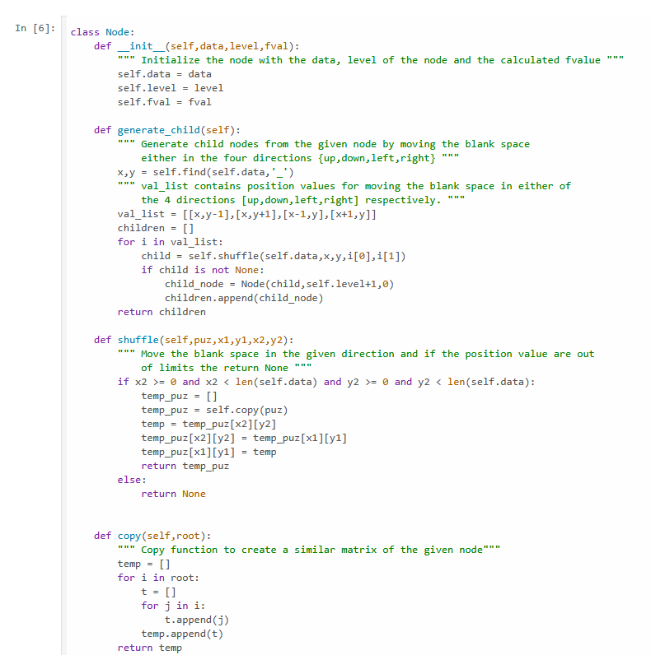

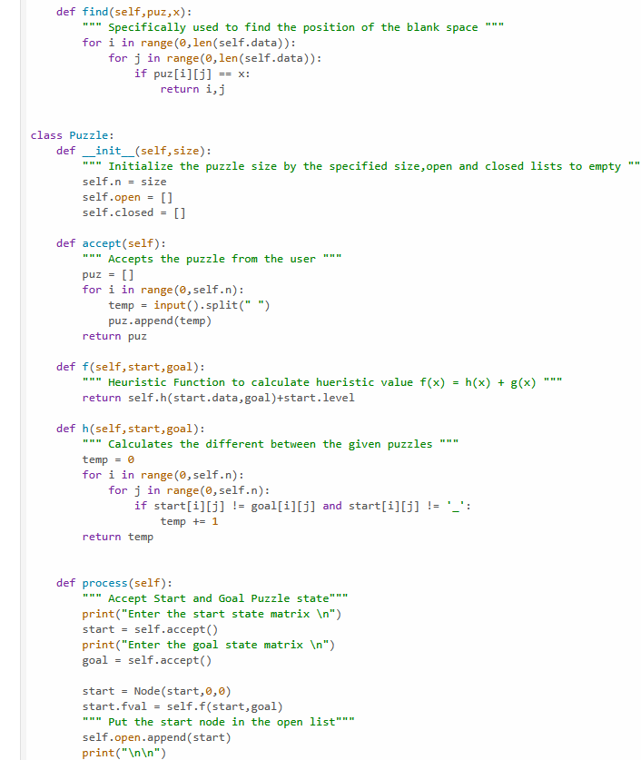

**Program 4 & Program 5**

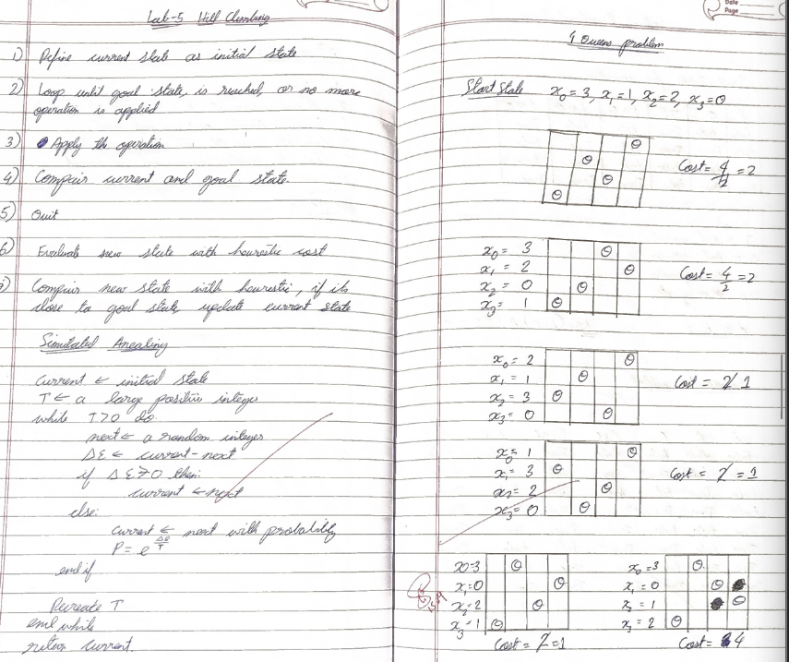Implement Hill Climbing search algorithm to solve N-Queens problem

Simulated Annealing to Solve 8-Queens problem

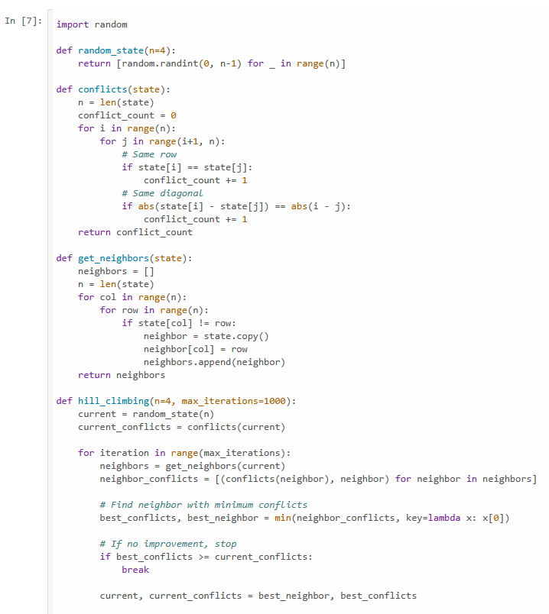 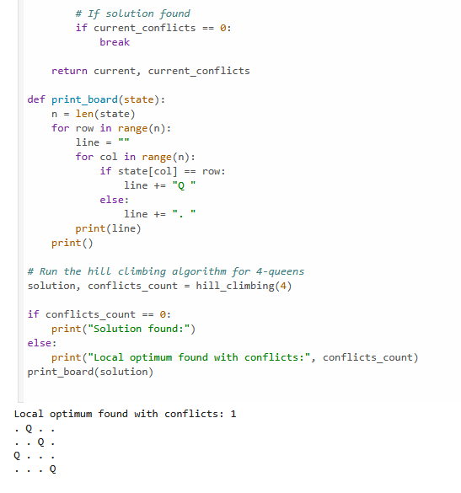

**Program 6**

Create a knowledge base using propositional logic and show that the given query entails the knowledge base or not.

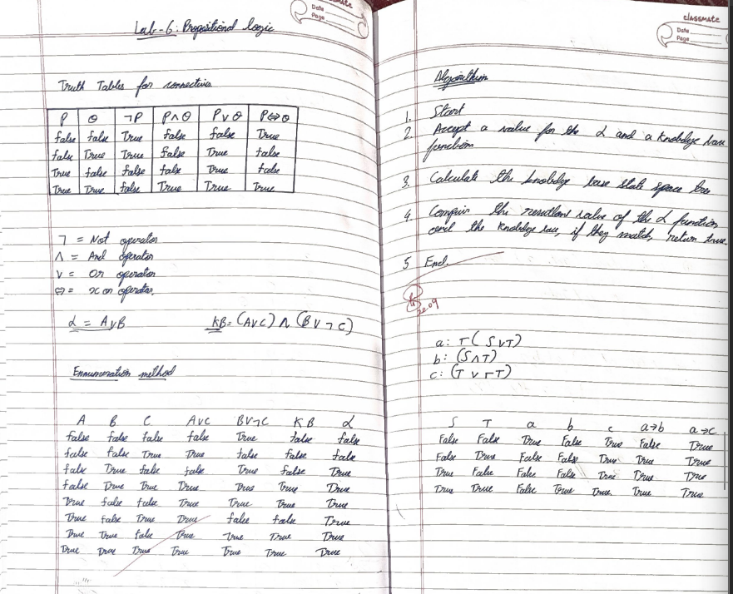

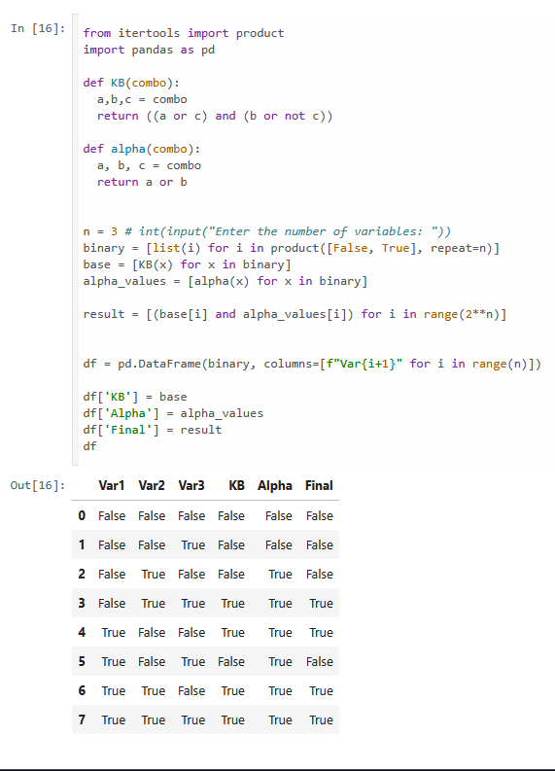

**Program 7**

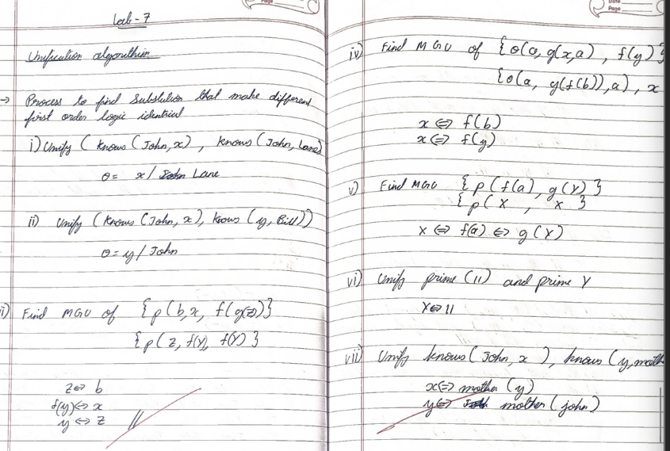Implement unification in first order logic

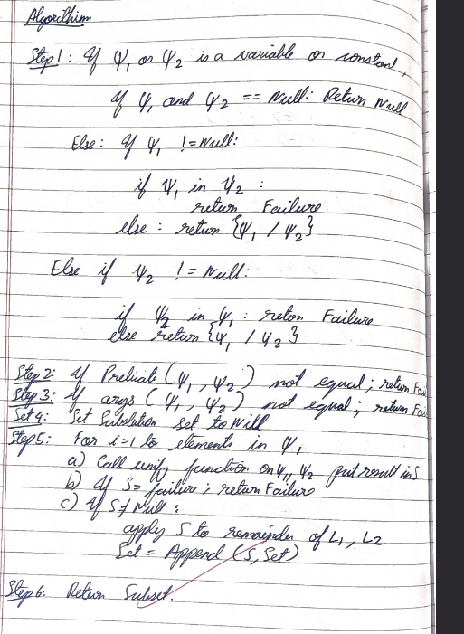

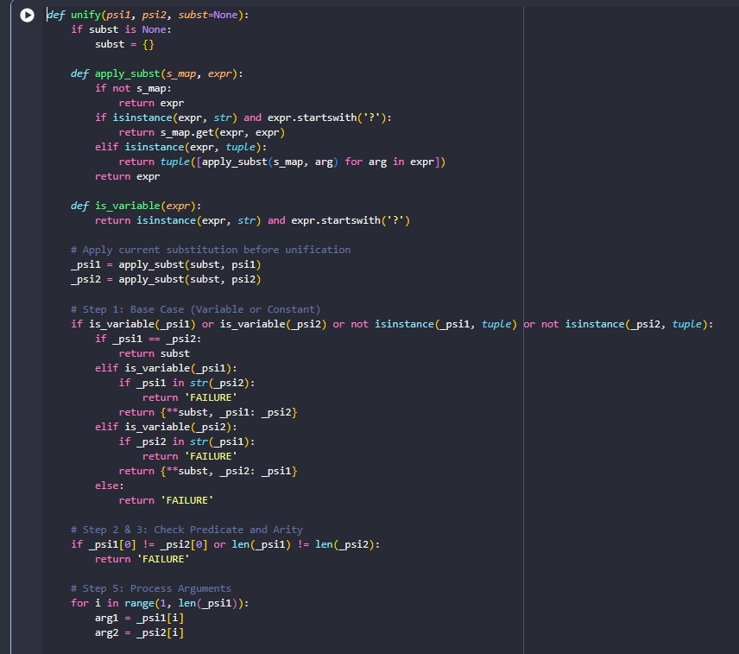 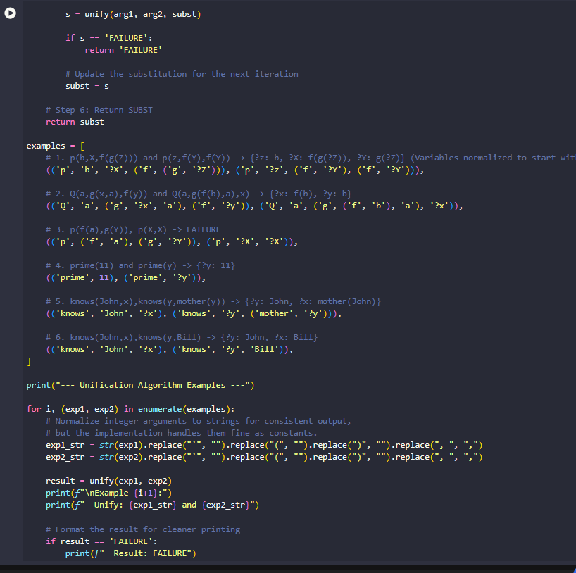

**Program 8**

Create a knowledge base consisting of first order logic statements and prove the given query using forward reasoning. 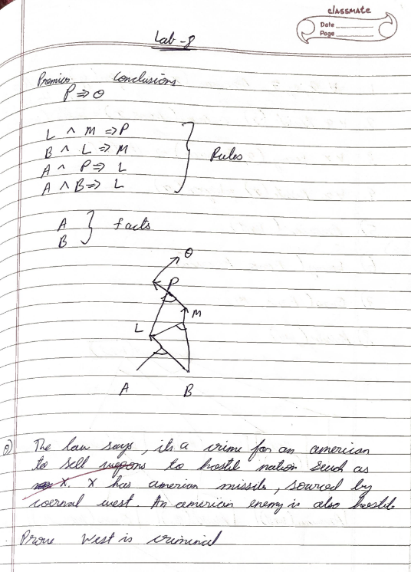

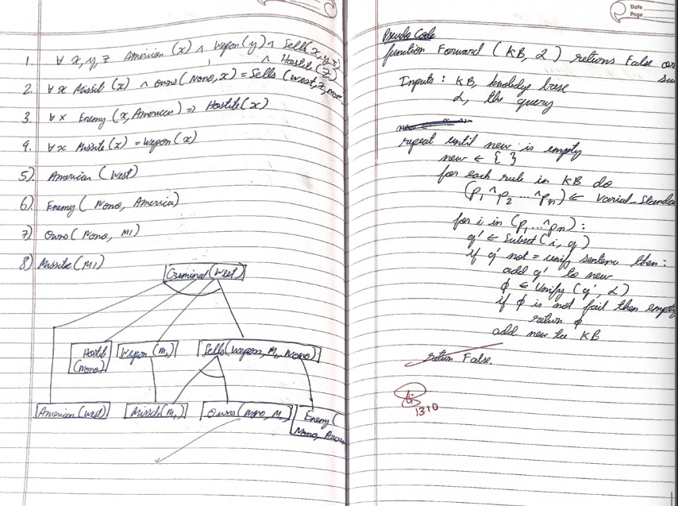 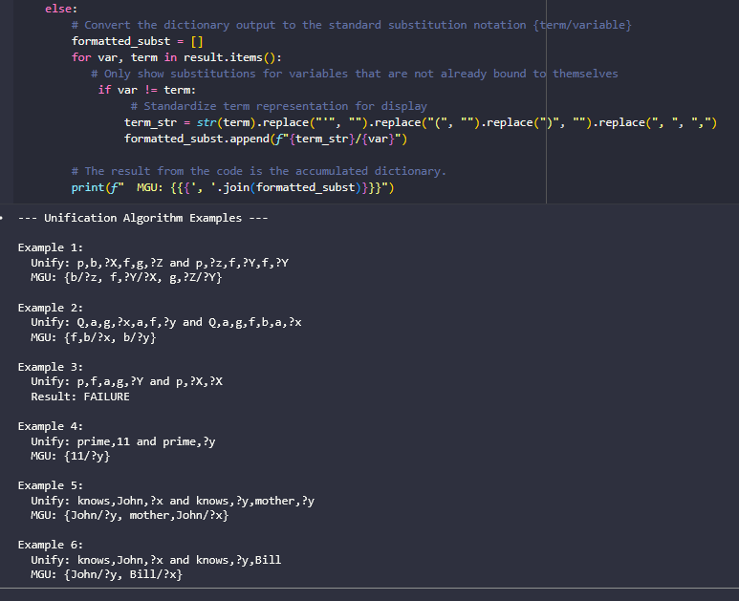 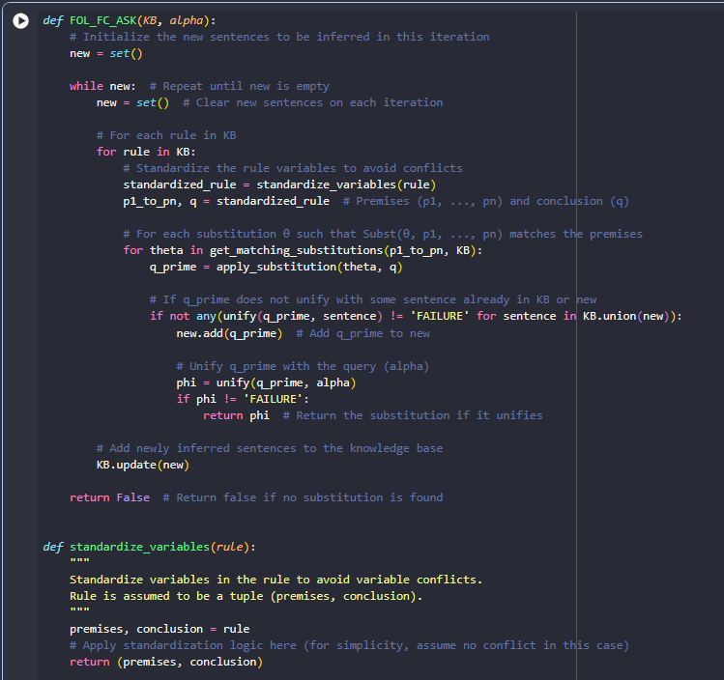 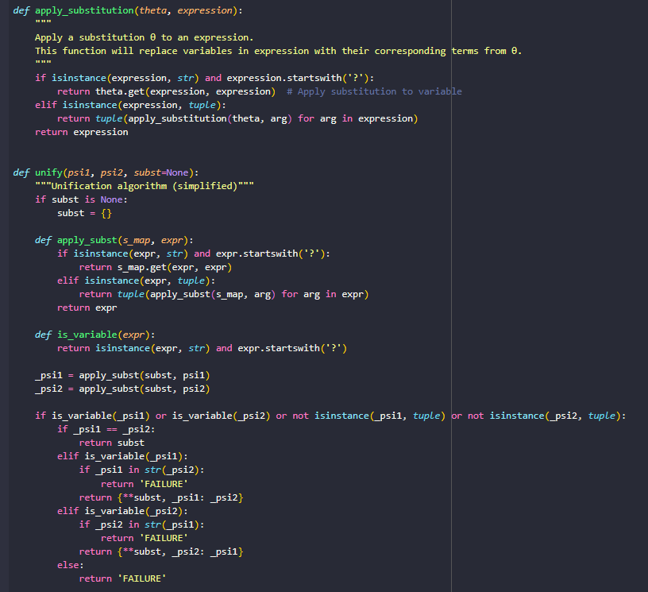 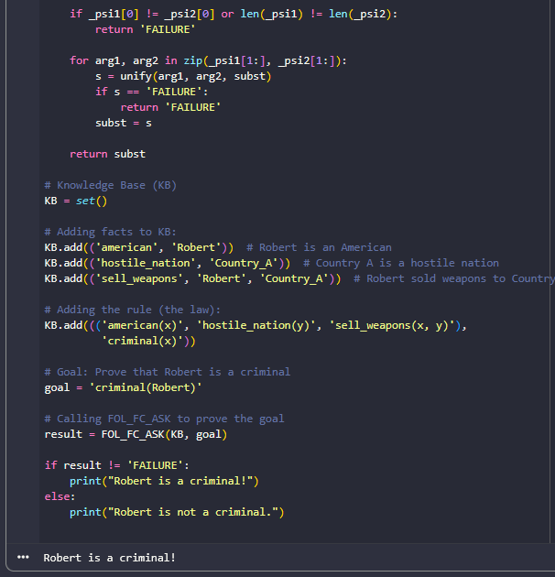

**Program 9**

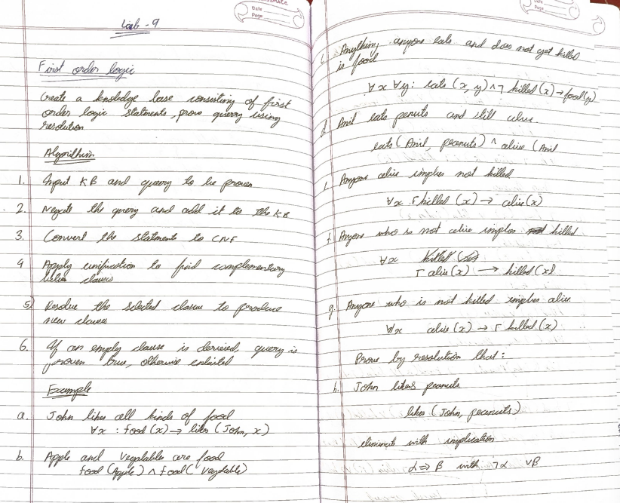Create a knowledge base consisting of first order logic statements and prove the given query using Resolution

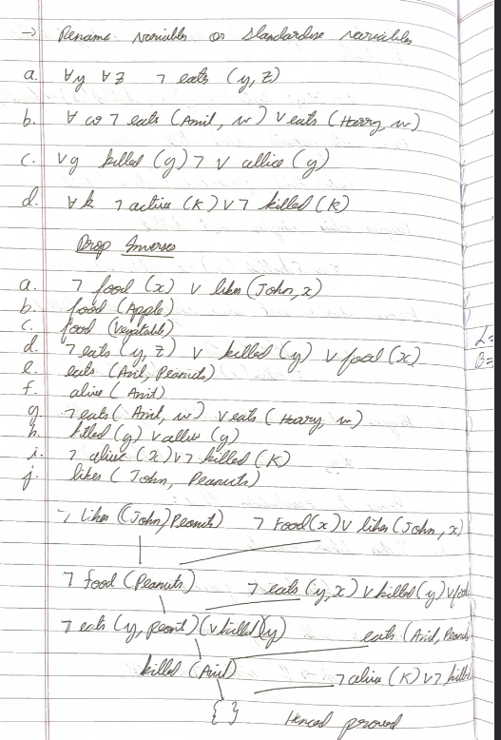

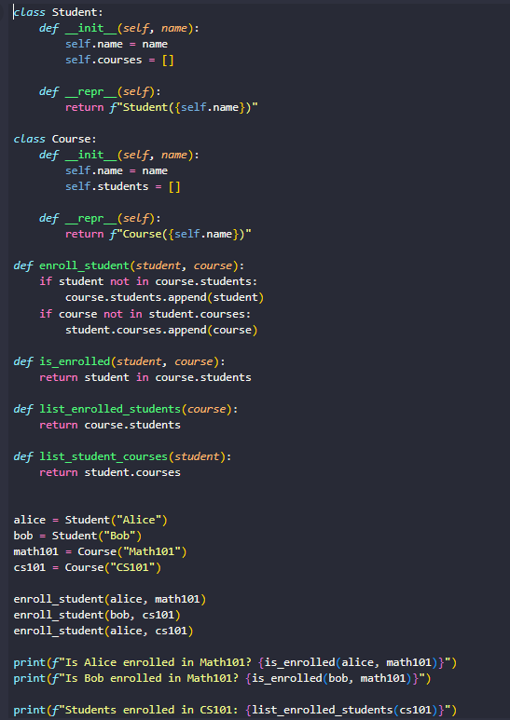

**Program 10**

Implement Alpha-Beta Pruning